List to go

Name: Ahmed Mohsen, ID: AA2200061
Name: Seif Rami, ID: SR2200251
Name: Abdelrahman Elsayed, ID: AE2301057
Name: Mohamed Adel Assal, ID: MA2201152

Lecturer Name:
Dr. Marwa
Assistant Lecturer Name:
Dr. Shorouk

Table of Contents
Table of Figures 3
Introduction 4
Project scope 5
Requirements 6
Functional Requirements 6
Non-functional Requirements 6
Technologies and Tools Used: 7
Architectural design: 8
Product Backlog: 9
Sprint 1 9
Sprint 2 9
Sprint 3 10
Sprint 4 11
Sprint 5: 12
Sprint 6: 12
Quality assurance: 12
Diagrams: 13
Manual Testing: 18
Sign up Testing: 18
Login Testing: 18
Forget password Testing: 18
Automation Testing: 19
Risk Management: 20
GitHub Link: 20
Link to Trello: 21

Table of Figures

Introduction

This document’s purpose is to provide an understanding of technical and non-technical aspects of the web application. It will also document tools used and the decisions that team has made. It will also serve to ensure that customer requirements are met, such as guaranteeing the application’s ease of use and the inclusion of different themes.

Project scope

List To Go is a simple to do list application that emphasizes user friendliness and a smooth experience. It incorporates features that enhance the user’s task tracking, including deadlines, editing existing tasks, and monitoring task progress.
Additional features are also planned for release – Calendar view, task reminders, drag-and-dropping tasks, and automatically repeating tasks.

Requirements

Functional Requirements
- Login: Login Page that provides users to log in to their account
- Registration: Allow new users to create an account
- Scheduling: Allow users to add or delete tasks in their to-do list
- Statuses: add status to each task (Complete, Hold, Incomplete)
- Description: a small description of each task
- Sorting categories: Filter to sort task by date or any other category
- Priority: Mark each task by their importance and urgency
- Reminders : Reminder for the task before the due date
- Progression bar(optional) : A bar that would display progression
- Themes: Changing themes from light to Dark

Non-functional Requirements
- Modern Gui : User friendly UI & simple
- Efficiency: Speed of processes and time efficiency (completing requests)
- Encryption Data: Keeping data safe and secure from breaches
- Ethical implications: no use of data in an unethical method
- Security: Making sure security measures are put in place to keep users safe and anonymous
- Usability: Application will focus on all the user’s needs and the design will be user centered

Technologies and Tools Used:

The web application’s back-end is written in Django. This is mainly because of Django’s extensive documentation and wide usage. It also provides solid solutions and built-in functionalities. Django is also used to interact with the database.
The front-end, on the other hand, uses React due to the seamlessness of its user interface building. Like Django, it is also used commonly and well documented.
To link the back-end and the front-end, the front-end (React) sends requests to Django’s API. Afterwards, Django responds with either data or a status/error response.
Trello, a kanban-style task management application, is used to help keep team members up-to-date and help with task organization.
GitHub was used as version control that provided efficient merging between all branches so team can work together.

Architectural design:

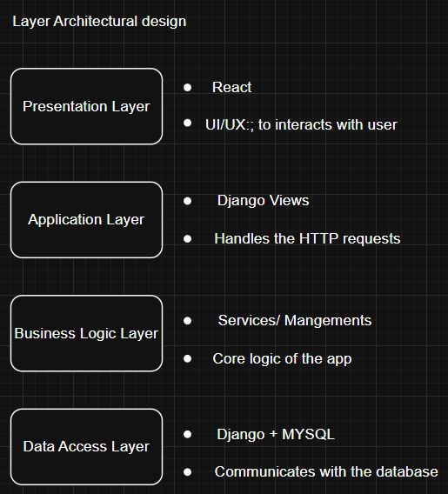

Product Backlog:

Sprint 1

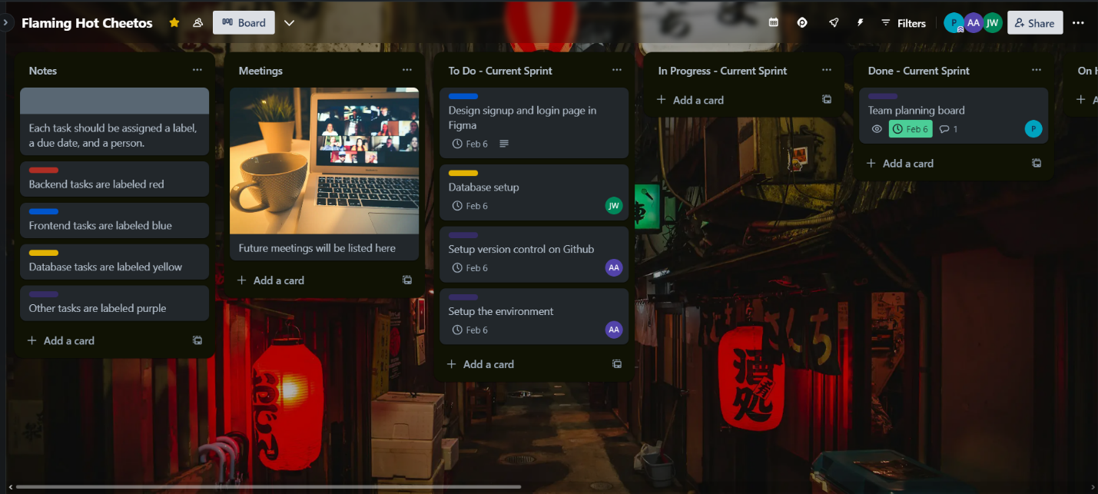

Sprint 2

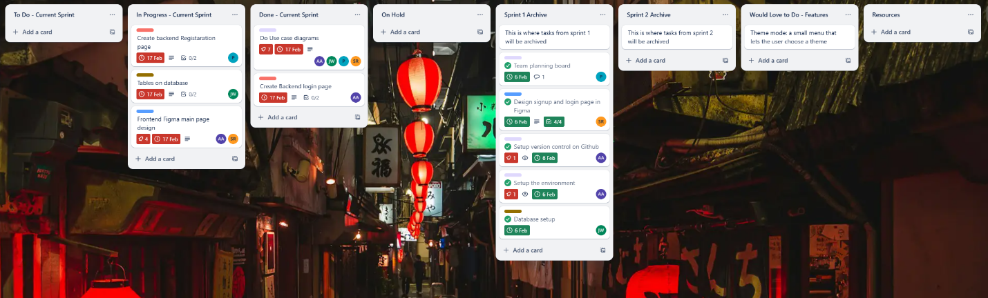

Sprint 3

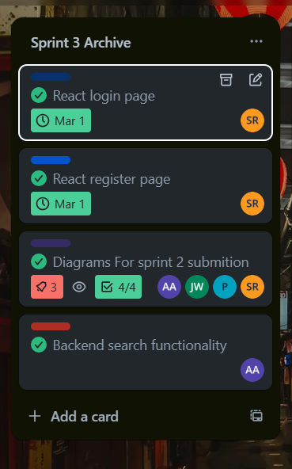

Sprint 4
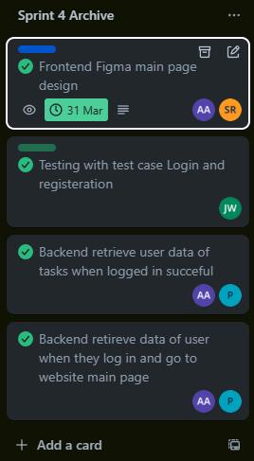

Sprint 5:
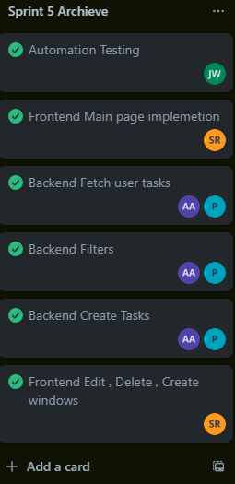

Sprint 6:

Quality assurance:

To ensure the delivery of high quality of the list to go app, a user friendly to do list website, we implemented both automated and manual testing strategies on different parts of the project. The QA focuses on verifying that the core functionalities of the website are working as expected and providing optimal user experience. Our approach to QA involved multiple testing techniques throughout the development phase. Automated testing was used to ensure core functionality, while manual testing was used to ensure seamless user interaction. The testing strategy focused on key aspects of the list to go website, such as login, task creation, and account recovery.
Types of QA Activities:
Automated Testing: Automated test scripts were written and used for key functionalities specifically:
login: The login process was automated to ensure users could seamlessly access their accounts using valid credentials.
Task Creation: Automated tests ensured that tasks could be successfully added, including verifying through the database that all the values were stored correctly.
Manual testing: Manual testing was used for tasks requiring user interaction, specifically:
Login: The login process was tested manually to ensure that users can log in correctly and ensure that error handling measures were taken, and errors messages were shown.
Sign Up: The sign-up process was also manually tested to ensure that new users could sign up easily and validation rules and error messages were implemented, and that the data was correctly stored in the database.
Password Recovery: The password recovery process was also manually tested to ensure that the users could successfully reset their password through a code sent to an input email and observed the new password change in the database.

Testing Techniques
Unit Testing: Automated script tests were written to verify the core functionalities of the website.
Integration Testing: Using Postman during the development phase, backend API endpoints were tested to ensure correct operation and response. This helped verify the backend logic was operating correctly before connecting to the frontend.
Functional Testing: Functional testing was also implemented to ensure that all the core features of the website operated correctly according to their specified requirements. The testing covered both frontend and backend interactions to confirm the user actions were handled correctly.

Diagrams:
Use case Diagram:
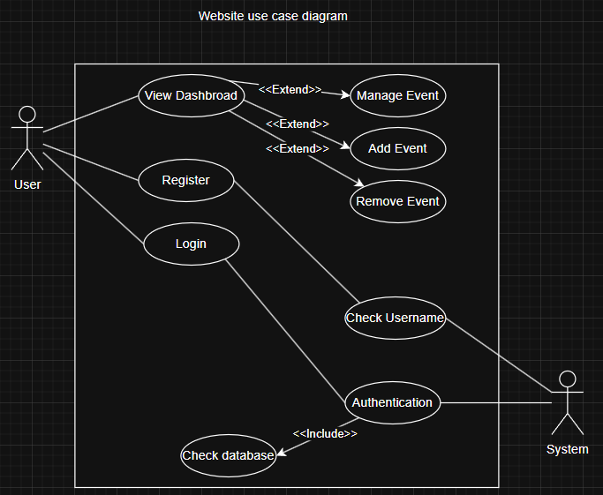

Activity diagram (User Registration):
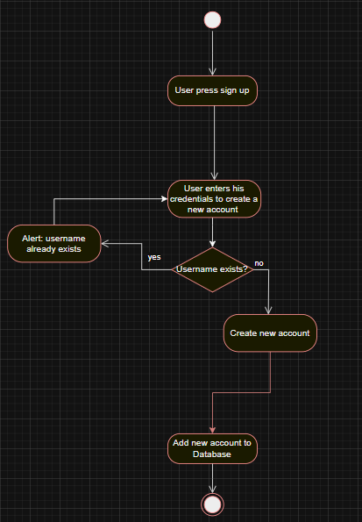

Sequential diagram (managing events):
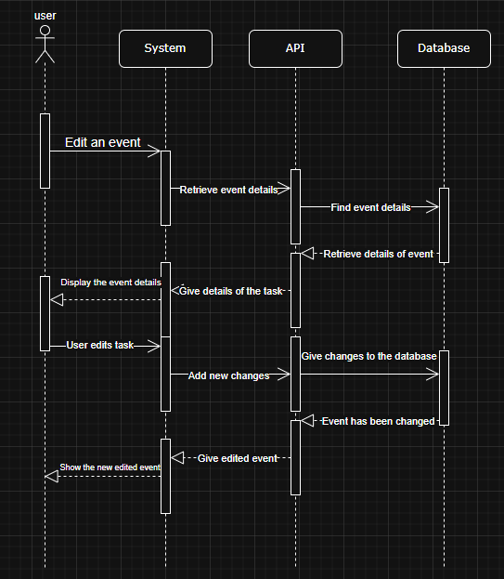

Sequential Diagram (Adding events):
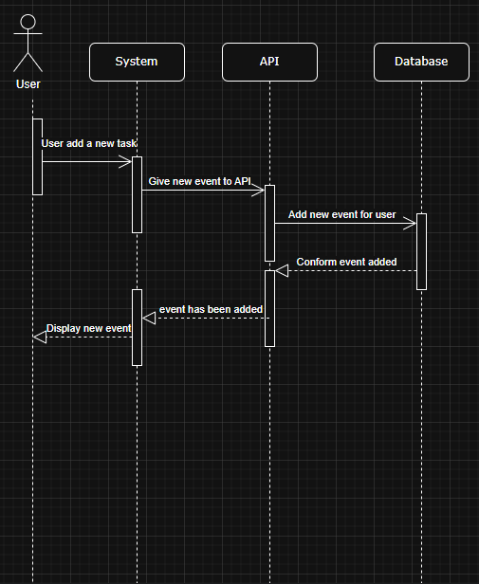
Activity Diagram (Login in):
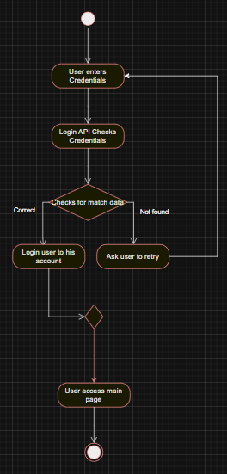

Misuse case diagram:
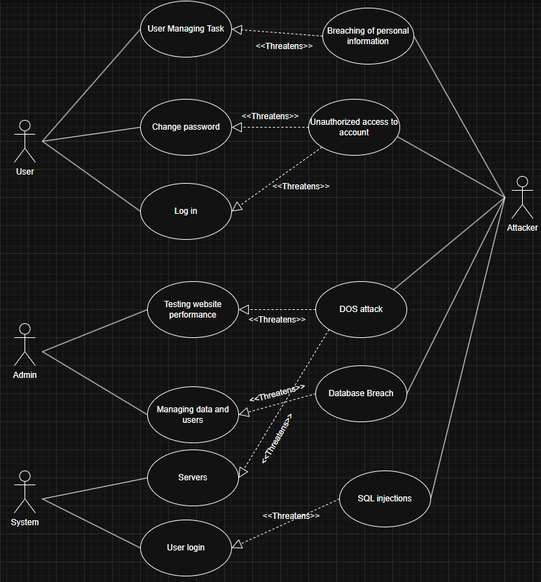

Sitemap:
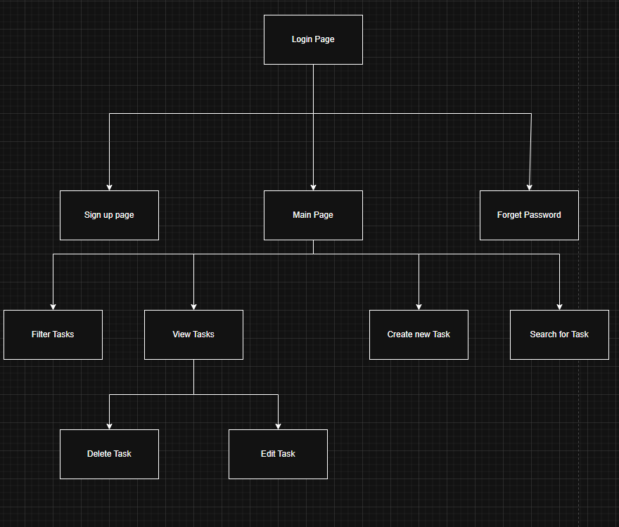

Manual Testing:

Sign up Testing:

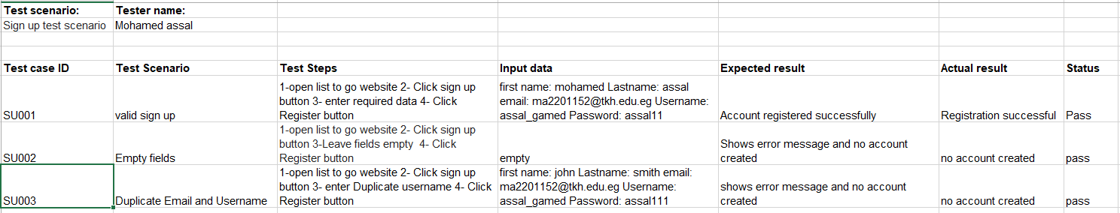
Login Testing:
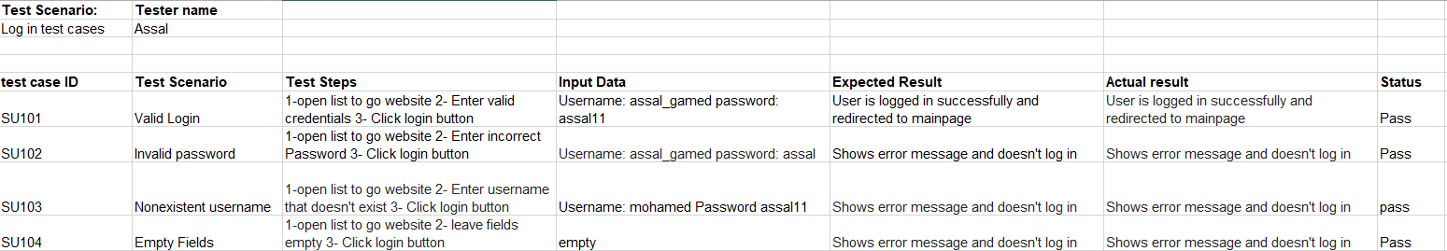
Forget password Testing:
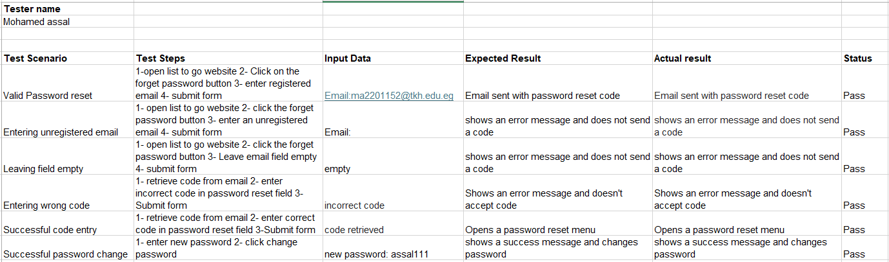Automation Testing:
This a script code that opens application and logs in and creates a task automatically:
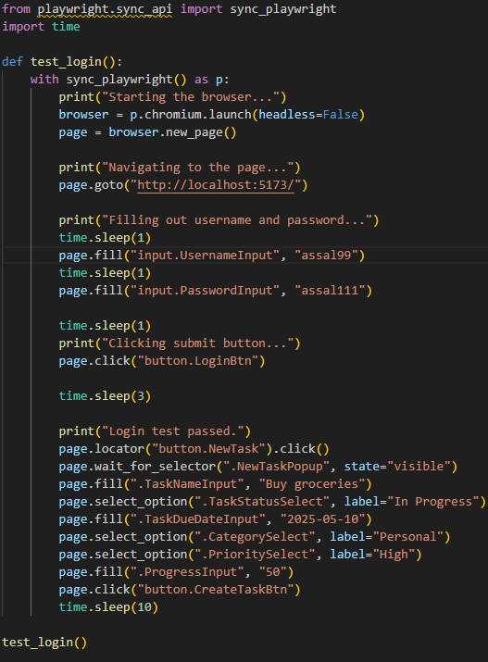

Risk Management:

Risk management is a process that identifies all the possible risks that can affect an organization either financially, reputationally, or operationally. Also assessing and finding solutions for such threats is essential for the benefit of the organization.

Steps in Risk Management:
- Risk Identification
- Risk Assessment
- Risk mitigation
- Monitoring and Reviewing
- Communication and Reporting

Risk we faced and dealt with:
R0) Integration: Issues integration between frontend and backend
Solution: Proper patience and team collaboration on the code while using react usetate methods to connect between them
R1) Performance problems: performance issues with code running for too long due to gasp animations
Solution: optimized gsap code with useeffects for better performance
R2) Third-Party dependencies: Api failure due to poor adjustment to some cases
Solution: covered all cases that lead to errors
R3) Unrealistic deadlines: some tasks took more time than required, especially for the frontend
Solution: Extended task deadlines

GitHub Link:

When accessing our GitHub repository you will be met with five branches. one for each team member. Each branch shows the team’s contribution to the master branch which is the main branch that gathers all individual branches into one complete branch/project
GitHub: https://github.com/Cookieking2490/List-to-go\

Link to Trello:

When accessing our Trello dashboard, you are met with a bord that displays each detail of how our project was created and innovated over time through meetings, sprints, and coordination. Archives showcases all the things that have been completed. If we are in a current sprint, then we save anything completed to the done tab and anything in progress in the progress tab . a fully immersive cycle to ensure a complete and successful project
Trello: https://trello.com/b/Qm214vVA/flaming-hot-cheetos

